Title: CAP
Subject: EEC 10

1. Some Facts  2. Need for protection?  4. How it worked  A. Pillars of the common policy  B. The price support mechanism: a verry special tratment  5. Results  A. Initial phase  B. Later development  6. Need for reform  A. 1992 Reform (MacSharry)  a. Drivers  b. The reform  B. 1999 and 2003 Reform  a. Drivers  b. The reform  C. Today’s agricultural policy | 1.7 % of the EU GDP and a modest contribution to growth, 5.0 % of labour force, 5.3% of imports, BUT 38% of budget (>70% in 80s)  It is the only entirely communitarian policy = financed entirely by the EU (nat gov are not giving money)  Why do they need protection?  In WW2 we experienced shortages.  Agriculture is a family business = fragmented, no economies of scale, no efficency  We need food (old but essential economy)  Agriculture is Risky (weather) + Time gap between consumer D and fwhen armers are able to increase S (growing more wheat takes time and I).  The post-war booming industrial sector was creating pressures for a potentially massive outflow of people from the rural areas to the new urban industrial centres. Two options:  - no intervention, let the mkt to the necessary adjustment => massive exodus.  - accompany the transition, while protectiong agriculture  “Multi-functionality” of agriculture: Farmers create a positive externality by managing natural resources, maintaining biodiversity, animal welfare  + Consider agricultre was way more important in the 50s (40% of share of empl ITA, excp Uk 4%), now <4% avg.  Objectives of the common policy est in Tretay of Rome 1957  stabilise markets  Increase productivity by promoting tech progress and the optimum utilisation of the factors of production  Ensure the availability of supplies  Ensure a fair standard of living for farmers (increase individual earnings) = guarantee reasonable prices  Principles of the common policy  All countries had some diff forms of support for agriculture (quotas or extra income support).  They had to harmonize the mkt, they created:  A unified market: free movement of agricultural products  Community preference: EU agricultural products are given price advantage over imported products (price support mechanism);  Financial solidarity: all expenses resulting from the application of the CAP are borne by the EU budget.  Community preference exercised trough the price support mechanism:  A price floor was set and implemented with flexible tariffs (CETs) to ensure that imports never pushed EU prices below the price floor. Floor is a political commitment to eu farmers: we know there is a lot of volatility, we promise you this is the price your are gonna get. The tariff is changed accordingly in otder to keep the prices unchanged. We cared more about farmers than consuemrs. For consumers the Pw was the best!  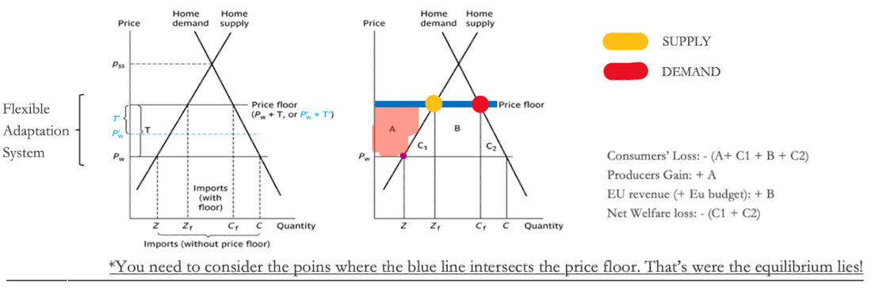  Initially, the CAP was well received:  Higher and stable prices to farmers ( income $↑$ )  Tariff revenues for the EU budget.  Consumers: higher p but more domestic food and lower dependence on imports, high p compensated by rising incomes + empathy with farmers  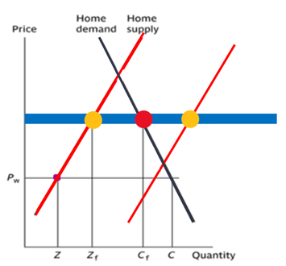  B. Then crisis began  Productivity gains: high guaranteed prices encouraged Investment + Agrochemical industry sprang up (pesticides, herbicides, fertilizers) + CAP rewarded output  Supply rose much faster than consumption => S shifts out => Now the internal mkt eq is below the price floor. The point is not if internal mkt eq => pw. We know ph > pw and that Eu is an importer. The point is that ph < pfloor! more than prohibitive tarff. There is an artificially high world price, you are actually selling to the EC:  - With a moderate tariff you have national supply < national demand  - With a prohibitive tariff you have national supply = national demand  - With a more than prohibitive tariff you have national supply > national demand  The basic intuition here is that for a given fixed price demand is fixed. But, as costs of production decrease (productivity) supply increases. As some point you will have supply > demand => Excess Supply. Basically the CAP price support meant that producers could produce any quantity... and they would always get their sales at the (high) price floor guaranteed...!!!  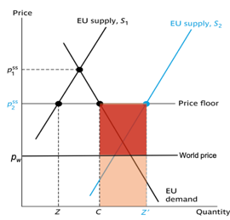  Eu basically started buying tons of wheat and butter, mostly wasted => EU started selling at cheap abroad at world prices. This form of dumping* was called “Export Subsidies” => EU became a net exporter of agricultural goods => All these market interventions started to raise the cost of the CAP for the EU Budget (at the beginning they were making money)  80% of the budget in the 70s  Problems:  Producers in the RoW (especially developing! Eu ) were damaged by Eu market closure + dumping  Before 1994 Uruguay Round, the WTO placed no ban on the dumping of agriculture, but agreement was coming closer  EU producers did not respond anymore to mkt signals (not real price as the key info)  Environmental problems and low quality, as producers had an incentive to produce as much as possible, no matter what! fertilizers, pesticides (environmental concerns è health problems)  Consumers were facing high prices, with regressive effects (poor spend a larger % of their income on food products).  Uneven distrivution of benefits: subsidies in proportion to production, large firms were benefiting the most  1992 REFORM (MacSharry)  Exogenous driver (= no longer feasible internationally):  • In 1986 Uruguay Round opened to discuss liberalization of international trade in agricultural products.  Endogenous drivers (= no longer feasible internally):  • Decreasing internal political support (FOR all the reasons up)  • Enlargements (Gre in 1981, Por and Spain in 1986) increased the number of people entitled to receive support.  Reform:  Reduce price floor, but introduce income support (cash granted to farmers) directly proportional to production (incentive to maximise prod)  Not regressive for consuemers: citizens do not pay as consumers but as taxpayers progressively via the EU budget.  Opens the EU market to extra-EU imports. GATT compliance.  No mkt distortions => EU prices were allowed to progressively converge to the world level. Surpluses fall and eu become net importer.  1999 and 2003 REFORMS  Semi-Exogenous driver:  The same level of income support to the 12 “agriculturally-biased” acceding countries would have put a great strain on the EU taxpayers.  Endogenous driver:  Remuneraiton on production: risk of over-exploitation of the land or the cattle, at the expense of the environment or food safety  Reform:  Degression: reduces direct payments for bigger farms, while new measures are also introduced to favor young farmers.  Cross-compliance: Links direct payments to compliance farmers with basic standards concerning environment, food safety, and more  Decoupling: linking aid to the potential fair income (extension of land, size of cattle etc..) of the farmer, not to the actual production. Fair bc resulting from a correct exploitation of the available resources  Rural development: Funds to promote quality, animal welfare, environment, rural development etc. Aimed at ppl living in the countryside to help them stay thetr and invest in theiur territories by opening b&bs and restaurants etc…  Significant reduction in CAP expndure as a % share of total expenditure.  +  TODAY’S PAC  Deeper focus on:  - sustainable and green develop, fight to climate change  - foster biodiversity and non productive element, preservese landscapes  - support generational renewal and vibrant rural areas  - foster innovation  Strenghtening Decoupling, Cross compliance, degression and rural development policies  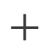  Ensure food and health quality, organic production. Helping concumers’ recognize the full benefits of a sustainable value chain may increase D for high quality products (and accept higher p) by doing promotional cmapaing giving specific infos on the produc and by fighting misuse and imitation of product names:  Ex. Geographcial indications:  - Protected Designeiton of Origin (PDO = DOP): products produced entirely  within a defined geographical area using methods and ingredients from the region  (ex. aceto balsamico tradizionale di modena).  - Protectical Geographical indication (PGI = IGP): food linked by its quality and  reputation to a region in which at least one stage of production, processing or  preparation took place (Aceto balsmaico di Modena).  - Traditional specilaity guaranteed (TSG): highlights traditional character, either in  the composition or means of production (e.g.Pizza Napoletana TSG baked in  wood-fired ovens using a traditional Neapolitan recipe)  - There is a special European logo for organically produced products    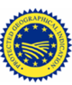  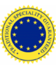  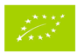  Still: bix expenditure in Eu budget = developing nations do not approve this approach

